Current Activities & Acquisitions

New Display Items
We have moved a large AS/400 plus expansion unit and tape library out to the display area. Space was created by installing two tier shelving for the typewriter collection. The back office area where these machines were kept has now been updated with racking to provide more storage.
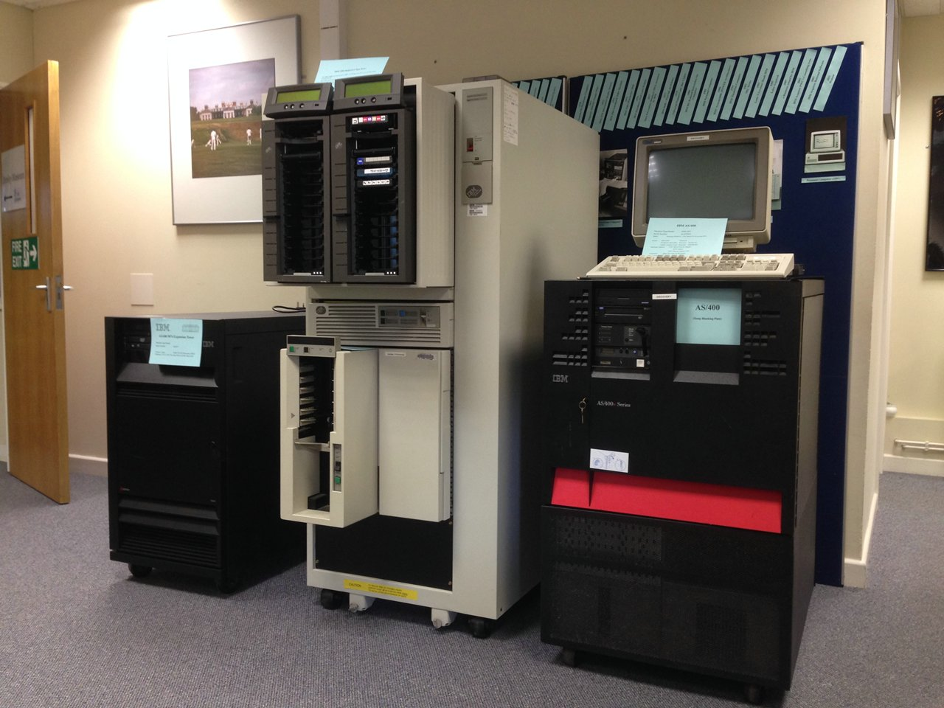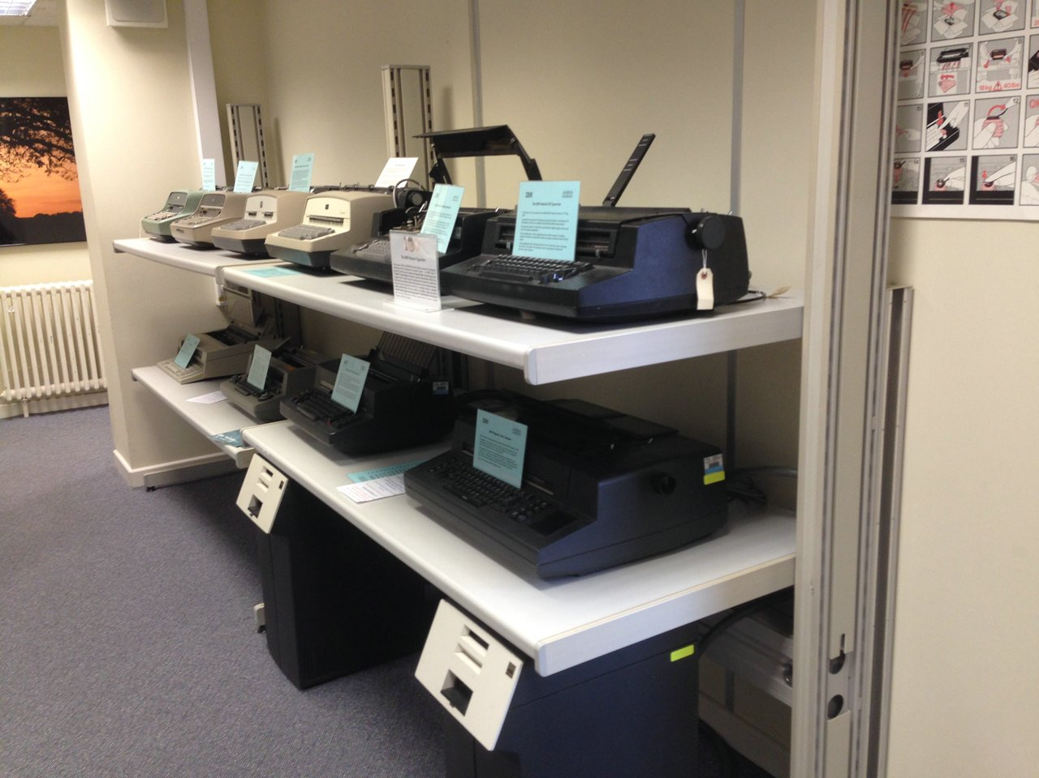

CashPoint Model
The model of the 2984 Lloyds CashPoint continues slowly. We have a full set of keytops printed on a 3D printer and finished off with vinyl transfers, and the keyboard & dispensing enclosure is partly built. Ready for processing is a piece of green Perspex with a red insert, together with a laser cut black vinyl sticker, for the top panel.
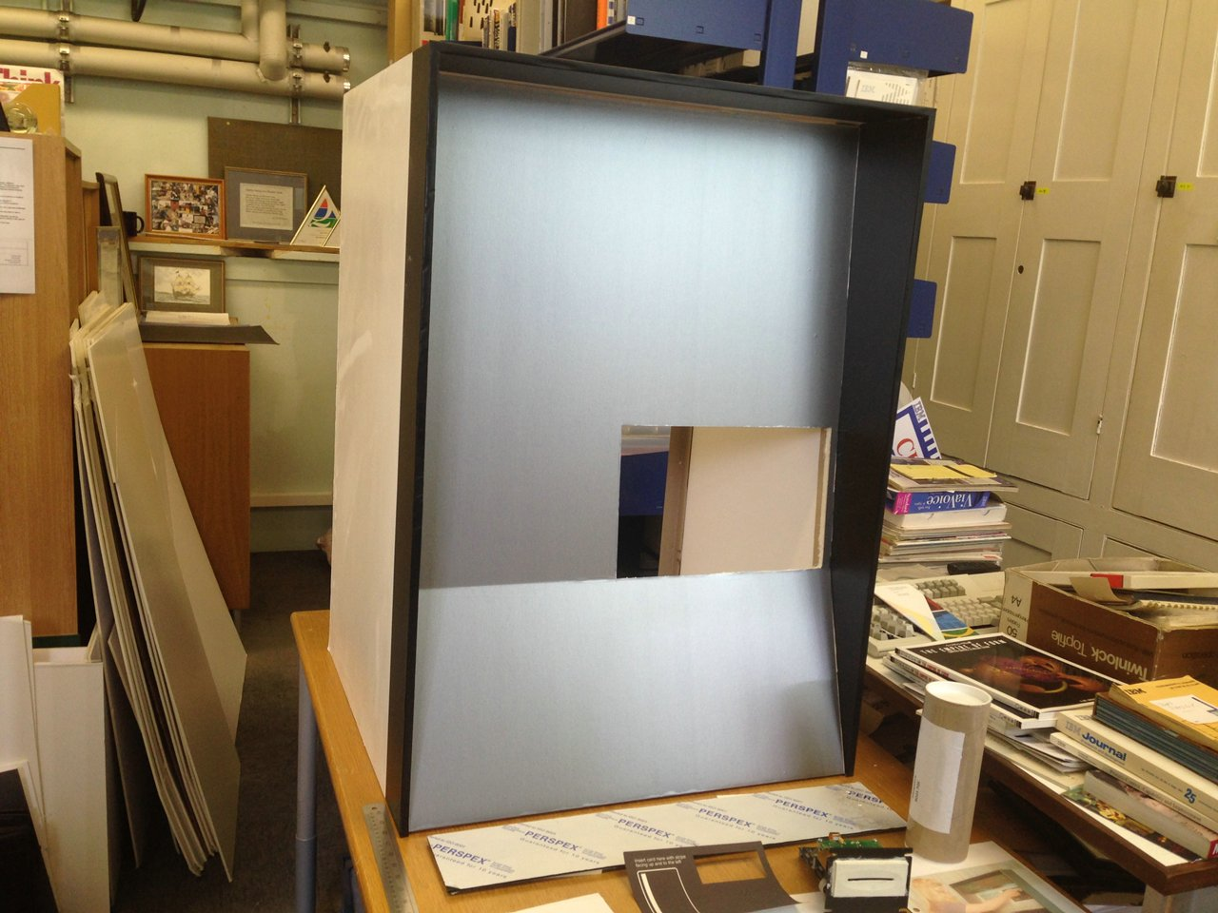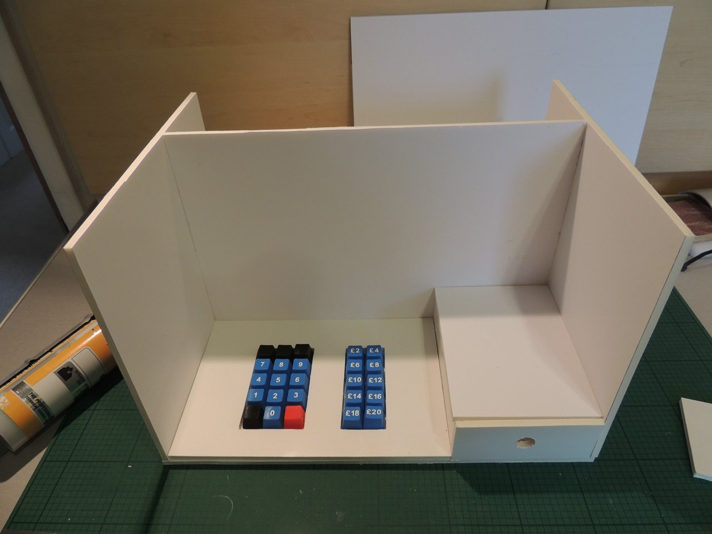

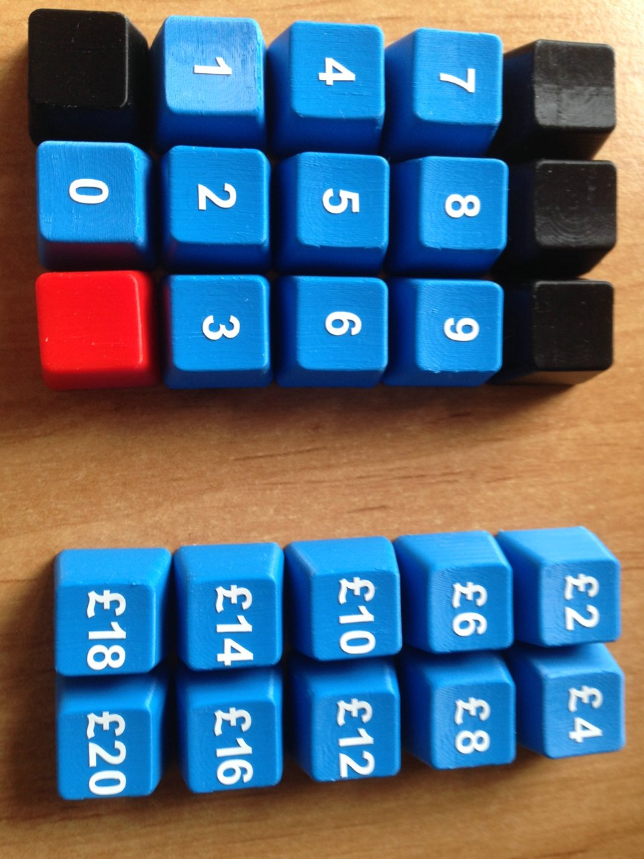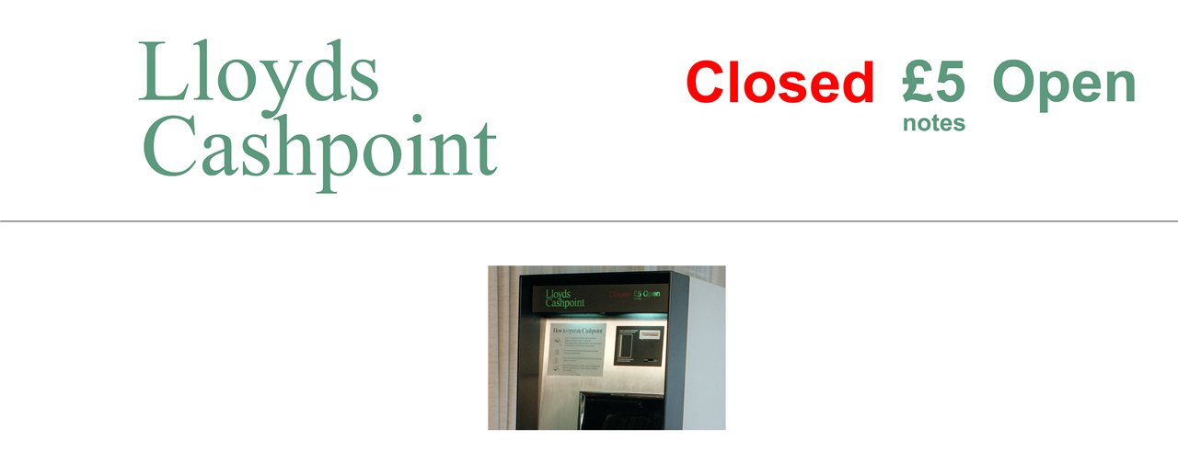

Other
We’ve moved a small display cabinet, made redundant after installing the new cabinets earlier this year, into the lower ground floor corridor.

The web site panorama images have been updated to show the modified display areas.

